Over the past two decades, from 1998 to 2018, average house price from 32 boroughs of London increased at least 1.8 times, with the top performers of more than 5 times. All 32 boroughs average house price data is summarized in **Figure1**. The top five boroughs that experienced the highest house price increase are listed in **Table 1**. If we further zoom into each individual borough, despite various house price increase rates, they all exhibit a price dip starting from 2008, which corresponds to the 2008 global economic meltdown, caused by the subprime mortgage crisis in the US (**Figure 2.** and **Figure 3.** Average house prices trend of the top and low performers, Hackney and North East, respectively).

**Figure 1.** Average house price of 32 London boroughs over the period of 1998 to 2018.

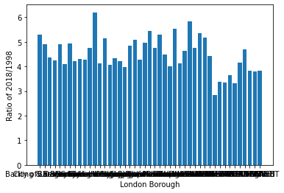

**Table 1.** Top five London boroughs that experienced the most average house price increase over the period of 1998 to 2018.

| No. | **London Borough** | **Avg House Price of 2018/1998** |
| --- | --- | --- |
| 1 | Hackney | 6.198286 |
| 2 | Waltham Forest | 5.834756 |
| 3 | Southwark | 5.516485 |
| 4 | Lewisham | 5.449221 |
| 5 | Westminster | 5.353565 |

**Figure 2.** Average house price trend of the high performer, Hackney borough.

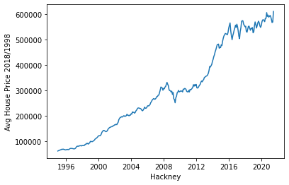

**Figure 3.** Average house price trend of the low performer, North East borough.

